STEPS TO CONFIGURE OSPF:

-----------

en

config terminal

**\*\*display the interfaces and their IP's in a network (excluding unassigned IPs -> the | e una part)\*\***

show ip interface brief | e una

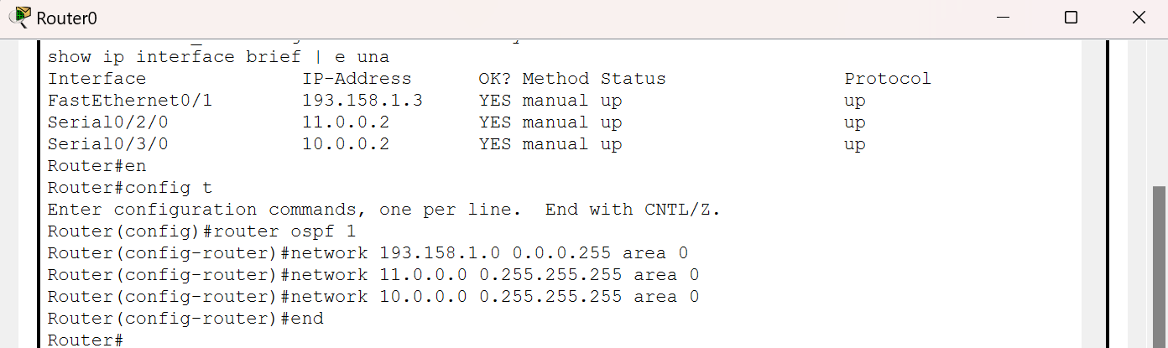

**\*\*constants are (router ospf 1) AND (area 0) in all routes\*\***

router ospf 1

**\*\*wild card mask is the inverse of subnet mask; EX: subnet:255.255.255.0 has wild card mask:0.0.0.255\*\***

**\*\*the ip addresses below when are written as xxx.xxx.xxx.0 (depending on the subnet mask if i was 255.255.0.0 then the ip addresses below would be in the format xxx.xxx.0.0)\*\***

network (ip address) (wild card mask) area 0

network (ip address) (wild card mask) area 0

network (ip address) (wild card mask) area 0

end

**\*\*should get a message similar to this:**

**00:14:09: %OSPF-5-ADJCHG: Process 1, Nbr 193.158.2.1 on Serial0/3/0 from LOADING to FULL, Loading Done\*\***

**\*\*if message got displayed , then ospf routing successful, ping two devices from both routers together by opening a pc->Command prompt-> ping (ip address of the other device under the other router)\*\***

**DEMO from Router6 to Router0:** 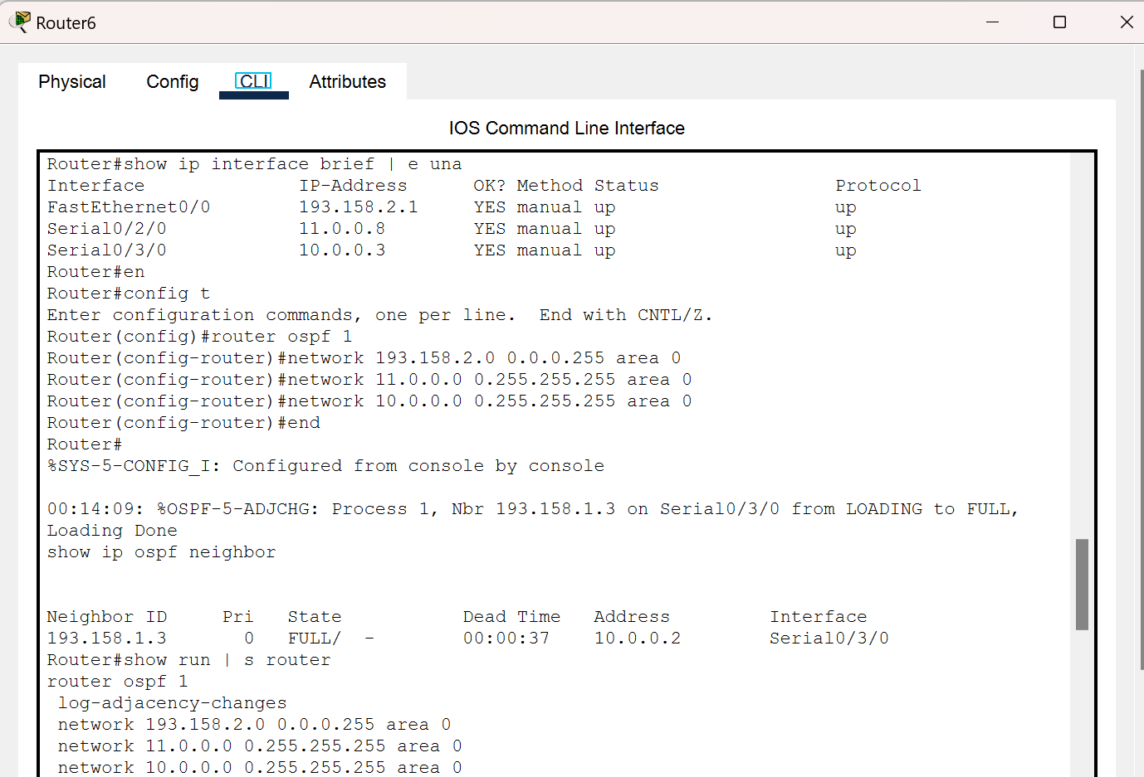

**\*\*Commands used above\*\***

**ip interface brief 🡪 displays devices & their IPs in a network**

**ip interface brief | e una -> displays devices & their IPs in a network except unassigned devices**

**show ip ospf neighbor -> check if there are any routers near that are connected to this router**

**show run | s router 🡪 summarize all the actions you have taken**

**note: any command that starts with “show…” should be written after the command “en” NOT “config t”**